10/12/2025 Briana-Yves 1-1 Meeting Minutes

We discussed the Deep Dream technique to interpret the features captured by the different encoding layers of the nnUNET model for segmenting the GBM tumor regions. The code has been implemented and being tuned.

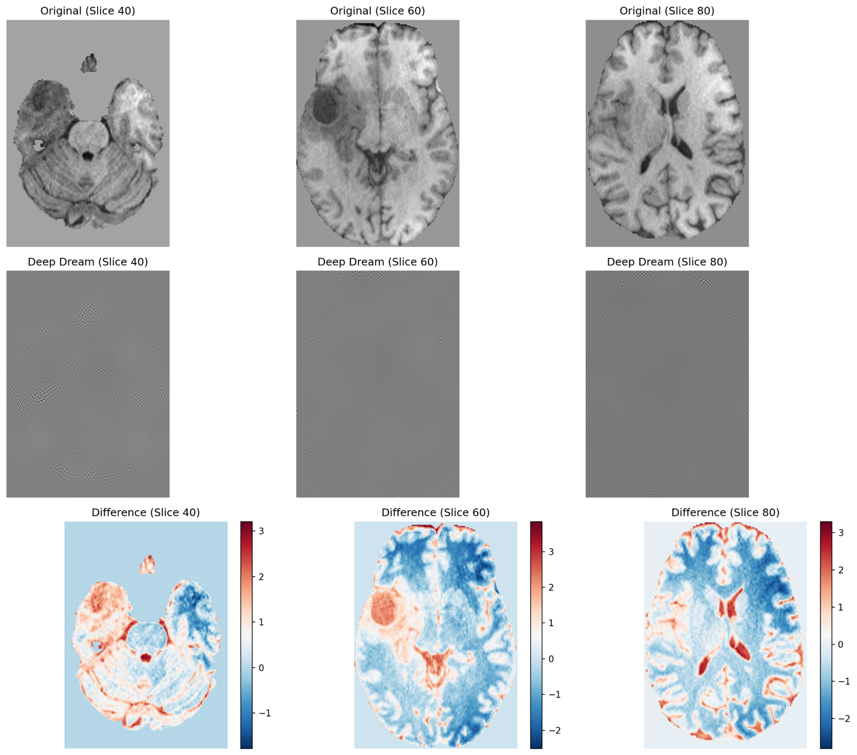

"Deep dream" is an image-filtering technique that involves using an image classification model and applying gradient ascent to an input image to maximize the activations of a specific layer.
Algorithm:
- Load the original image.
- Define several processing scales ("octaves") from smallest to largest.
- Resize the original image to its smallest size.
- For each scale, starting with the smallest (i.e., current one): - Run gradient ascent - Upscale the image to the next scale - Reinject the detail that was lost during upscaling.
- Stop when we return to the original size. To recover the detail lost during upscaling, simply take the original image, reduce its size, upscale it again, and compare the result to the (resized) original image.

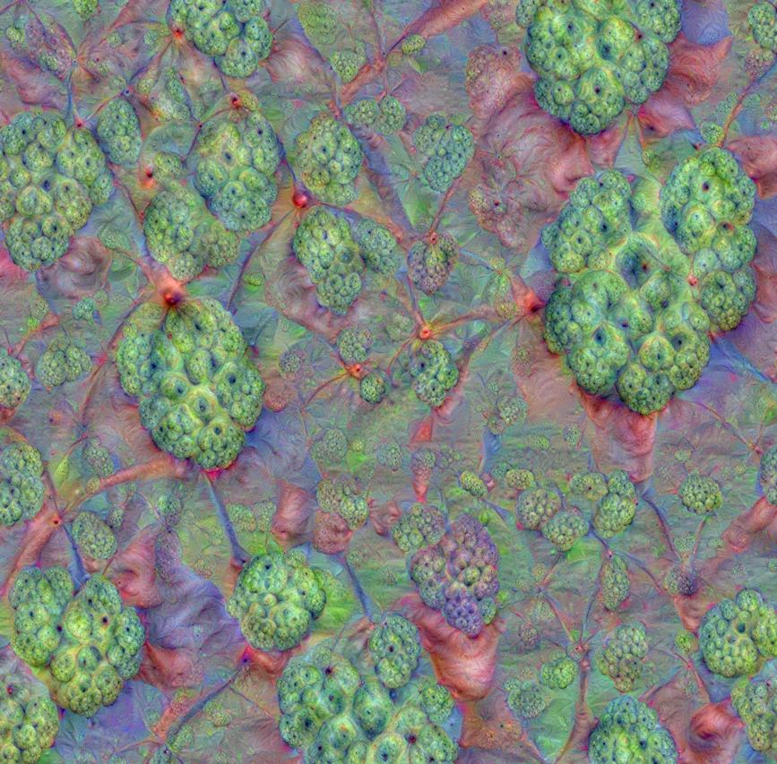
Example of Deep Dream Generated Image
(Custard Apple, May 16, 2015, by Alexander Mordvintsev)

